ASR VW eTracker Planned Pick up date changes

DATE: 2016.07.01

Requestor: Yeo, Bee Yen Goh

1. **Planned Pick-up date** **base on e-tracker input.** 
   1. Both Container Alert report will be retrieve “Planned pick up” from e-Track – Tracking list field – “Planned Pick up date”
   2. During shipment creation, the Planned pick date will default to 2 days before ETD date.
   3. For any changes of planned pick up date, users have to update in e-tracker.
2. Container Alert report – PENDING : This report will trigger outstanding container update based on Planned pick up in e-tracker. ( <= Planned Pick up date)
3. Container Alert Report – OVERDUE : no changes to this report. Report will trigger outstanding overdue containers which is 1 day before ETD

**Report:**

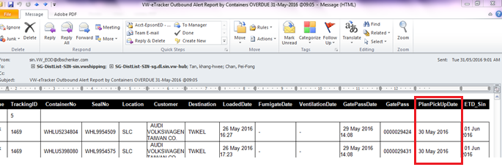

**e-Tracker input – Planned Pick up date:**

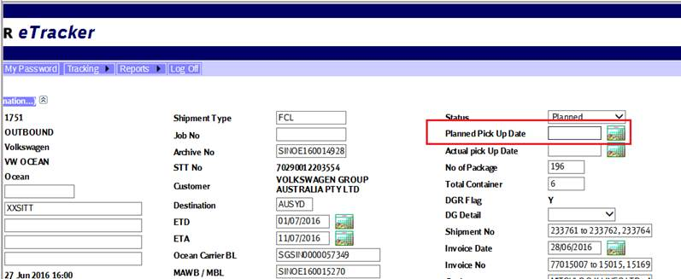

Update and changes:

Report:

1. Alert Pending report
2. Dashboard listing – plan pickup date to get input from Entry Tracking list

EOD

1. EOD- import CIS report , to default Plan Pickup date to 2 days before ETD

Entry:

1. E-tracker – tracking list update validation , add validate Plan pickup date update, the date should be before ETD date for the shipment . ( by Yusming , to-be update)